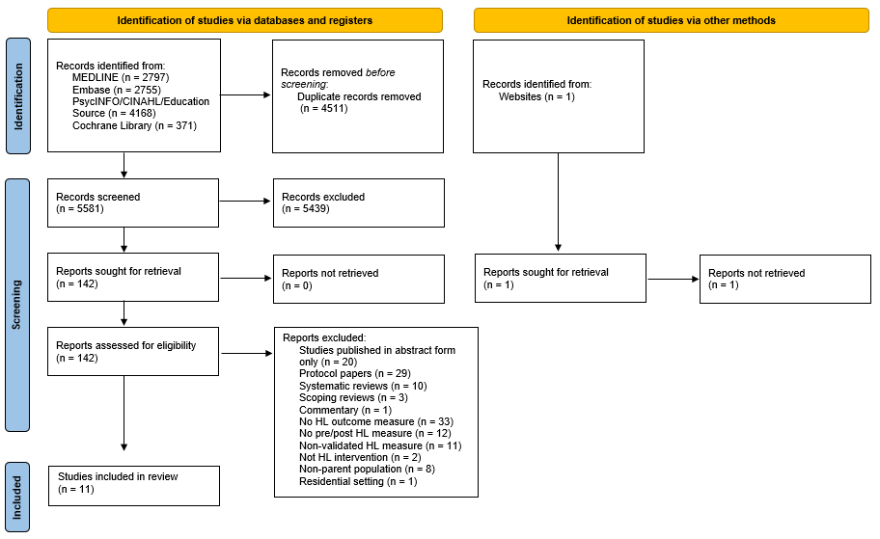

Supplemental Figure 1. PRISMA flow diagram of study identification, screening, and selection process

